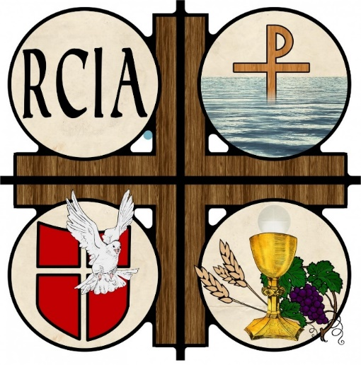

The Rite of Christian Initiation of Adults

Do you want to become Catholic?
Do you want to find out more about the Catholic faith?

Do you want to learn more about your faith?

Have you not yet received all the Sacraments?

If any of these questions applies to you, we would love to help you on your journey!

How?
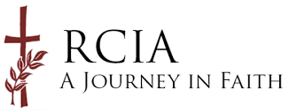
Spend 1½ hours each Thursday evening exploring the Catholic Faith
When & Where?
Programme commences Thursday14th October 2021
St Mary’s Hall, Chapel Lane, Belfast BT1 1JJ
For more information
Email: rcia@downandconnor.org Telephone: Fionnuala 07702073895

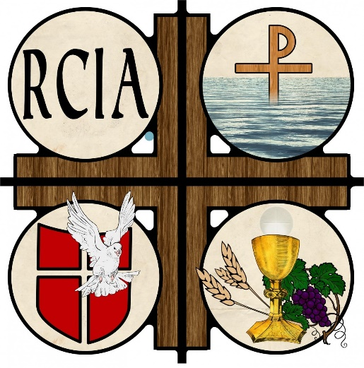
The Rite of Christian Initiation of Adults

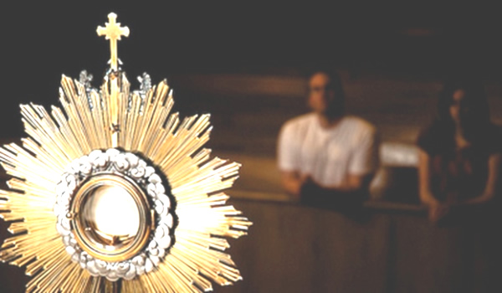
Do you want to learn more about your faith?

Have you not yet received all the Sacraments?
Do you want to learn more about the Catholic faith?
Do you want to become Catholic?

If any of these questions applies to you, we would love to help you on your journey!

How?
Spend 1½ hours each Thursday evening exploring the Catholic Faith
When & Where?
Programme commences Thursday14th October 2021
St Mary’s Hall, Chapel Lane, Belfast BT1 1JJ
For more information
Email: rcia@downandconnor.org Telephone: Fionnuala 07702073895

