MARY

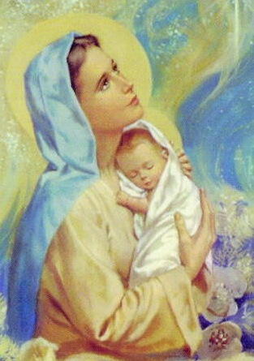
Mary

Faith | - Mary is the Mother of God  - God loved Mary in a very special way
Values / Morality | - Respect for Mary as Mother of God  - Respect for our mothers/families
Points for  Discussion | - Annunciation  - Nativity Story  - Characteristics of Mary  - How Mary looked after Jesus  - The Holy Family  - Our mothers  - Rosary as a special prayer to Mary
Prayers | - Mary's Love
Sacred Space | - May Altar consisting of:  - blue cloth  - candle  - children's bible  - statue of Mary  - children's pictures of Mary  - rosary beads
Children's Bible Stories | Suggested links with scripture:  - The Annunciation, Luke 1:26-38  - The Birth of Jesus, Luke 2:1-20
Songs & Nursery  Rhymes | - Jesus in Nazareth

Books

Links with Family

Prayers

Mary's Love
Mary, you love your son Jesus;
I know you love me too.
Help me every day,
to do the things that I should do.

Songs and Nursery Rhymes

Jesus in Nazareth
Jesus lived in Nazareth;
in a little house of stone.
With Mary and with Joseph;
in a very happy home.

Mary cared for him so well,
she taught him how to pray.
She cared for him with Joseph,
every night and every day.

