CHRISTMAS

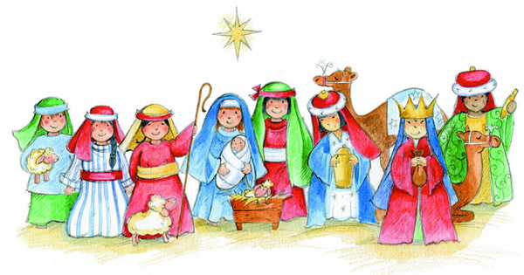

Christmas

Faith | - Jesus is the Son of God  - Mary is the Mother of Jesus  - The Holy Family
Values / Morality | - Concern for others  - Gratitude for what we have
Points for  Discussion | - Annunciation  - Mary, Joseph, Baby Jesus  - Shepherds  - Kings  - Gifts  - Giving presents  - Sharing and caring  - Helping people less fortunate  - Joy of Christmas
Prayers | - I want to Look for Jesus  - Thank you God for Jesus
Sacred Space | - Red cloth  - Candle  - Religious Advent Calendar  - Advent Wreath  - Crib  - Nativity story-book
Children's  Bible Stories | Suggested links with scripture:  - Birth of Jesus (based on Luke 1-2)
Songs & Nursery Rhymes | - Away in a Manger  - Down in Bethlehem  - Babies

Books | God's Littlest Angel  By Alan and Linda Parry  Published by Tynedale House Publishers  ISBN-10: 0842311777  Silent Night (My First Nativity Story)  Illustrations by Julie Fletcher  Available from Marks & Spencer  The Christmas Star  Published by Priddy Books  The Christmas Bible Storybook  A Bible Friends Bible Story  Published by Scripture Union  ISBN-10: 1844272915  The Nativity  Illustrations by Estelle Corke  Published by the Book Studio  Little Owl and the Star (A Christmas Story)  By Mary Murphy  Published by Walker Books Ltd  ISBN-10: 0744588022  The Christmas Story Book and Jigsaw  Illustrated by Stephen Holmes  Published by Haldane Mason Ltd  ISBN-10: 1905339658  Baby Jesus (Book and Play Puzzle)  Published by Ladybird  What Happened at Christmas?  By Alan and Linda Parry  Published by Tynedale House Publishers  ISBN: 9780842383776
Links with Family | - Mass on Christmas Day  - Nativity Play

Prayers

I Want to Look for Jesus
I want to look for Jesus.
Live like Jesus
and love Jesus.

Thank you God for Jesus
Thank you God for Jesus;
is the prayer we say.
Thank you God for Jesus;
born on Christmas day.

Songs and Nursery Rhymes

Away in a Manger
Away in a manger, no crib for a bed
the little Lord Jesus lay down His sweet head.
The stars in the bright sky looked down where He lay,
the Little Lord Jesus asleep on the hay.

The cattle are lowing, the baby awakes
but little Lord Jesus no crying he makes.
I love thee Lord Jesus, look down from the sky
and stay by my bedside 'till morning is nigh.

Be near me Lord Jesus, I ask thee to stay,
close by me for ever and love me I pray.
Bless all the dear children in thy tender care,
and take us to Heaven to live with thee there.

Down in Bethlehem
Guess what! A baby boy was born.
Guess what! A baby boy was born.
Guess what! A baby boy was born.
Down in Bethlehem.

We found him in a manger there.
We found him in a manger there.
We found him in a manger there.
Down in Bethlehem.

And wise men travelled from afar.
And wise men travelled from afar.
And wise men travelled from afar.
Down in Bethlehem.

The shepherds came with little lambs.
The shepherds came with little lambs.
The shepherds came with little lambs.
Down in Bethlehem.

And angels sang the night away.
And angels sang the night away.
And angels sang the night away.
Down in Bethlehem.

Guess what! A baby boy was born.
Guess what! A baby boy was born.
Guess what! A baby boy was born.
Down in Bethlehem.
Babies
Rock the baby in my arms,
hold him snug and tight;
lay him in his little cot and gently kiss good night.

Dear Father God keep babies safe, in your loving care;
thank you for sending Jesus for all of us to share.

Rock the baby in my arms,
hold him snug and tight;
lay him in his little cot and gently kiss good night.

