AUTUMN

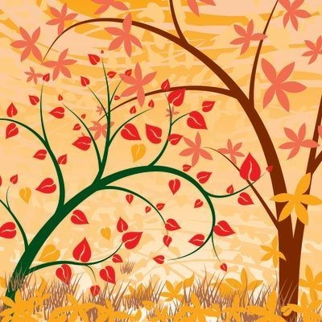

Autumn

Faith | - God made the world
Values / Morality | - Caring for God's creation  - Sharing the gifts of God's creation
Points for  Discussion | - Nature in autumn – trees, animals, birds  - Hibernation  - God’s care in autumn  - Fruits of autumn  - Colour
Prayers | - Autumn Leaves  - Autumn  - Prayer Service 'Harvest Festival'
Sacred Space | - Cloth in an autumn colour  - Candle  - Children's Bible stories  - Leaves, acorns etc  - Leaf prints
Children's
Bible Stories

Songs & Nursery  Rhymes | - Frisky Squirrel  - The Leaves are Falling Down  - Seed Song
Books | Thank You, God : Prayers for Little Hands  Board book by Lois Rock, illustrations by Kay Widdowson  Published by Lion Hudson  ISBN-10: 0745961622

Why Do Leaves Change Color?
By Betsy Maestro, illustrations by Loretta Krupinski
Published by Collins
ISBN-10: 0064451267

The Very Helpful Hedgehog
By Rosie Wellesley
Published by Pavilion Children's Books
ISBN-10: 184365198X

Ferdie and the Falling Leaves
By Julia Rawlinson, illustrations by Tiphanie Beeke
Published by Gullane Children's Books
ISBN-10: 1862336792

Autumn (Read & Learn: Seasons)
By Monica Hughes
Published by Raintree
ISBN-10: 1844213447

Links with Family | - Prayer Service 'Harvest Festival'
Prayer

Autumn Leaves
Autumn leaves are falling down
red, yellow, green and brown.
Hedgehog sleeps without a sound,
thank you God as the seasons come round.

Autumn
For fun in the park, we thank you God;
for autumn fruits, we thank you God;
for little squirrels we thank you God.
Thank you God.
Amen

Prayer Service

Harvest Festival

Preparation: Set up sacred space. Include a selection of fruit and vegetables.

Light a candle.

Teacher: Each season brings something new for us to see and enjoy.
With sunny days and rainy days our crops grow taller.

Fruit and vegetables ripen ready for us to harvest.
Thank you God for all the food we have to eat.
Amen

Child: My favourite fruit is ...

Response: Thank you God for ...

Child: My favourite vegetable is ...

Response: Thank you God for ...

Teacher: Let us remember the people who do not have enough to eat.

Children: God bless all the people who do not have enough to eat.
Help us to be kind and to share.

All: The Seed Song.

Songs and Nursery Rhymes

Frisky Squirrel
(Tune: The Grand Old Duke of York)
Oh, the frisky little squirrel
he gathers nuts and seeds.
He hides them for the winter months
so he’ll have all he needs.

The Leaves are Falling Down
(Tune: Farmer in the Dell)
The leaves are falling down,
the leaves are falling down.
Red, yellow, green and brown,
the leaves are falling down.

The Seed Song
Seeds are planted deep, deep, deep.
In the ground they sleep, sleep, sleep.

God sends sunshine bright, bright, bright.
Raindrops falling light, light, light.

Seeds are planted deep, deep, deep.
In the ground they sleep, sleep, sleep.

Gentle breezes blow, blow, blow.
Little seeds they grow, grow, grow.
Grow, grow, grow, grow.

