NEW SCHOOL

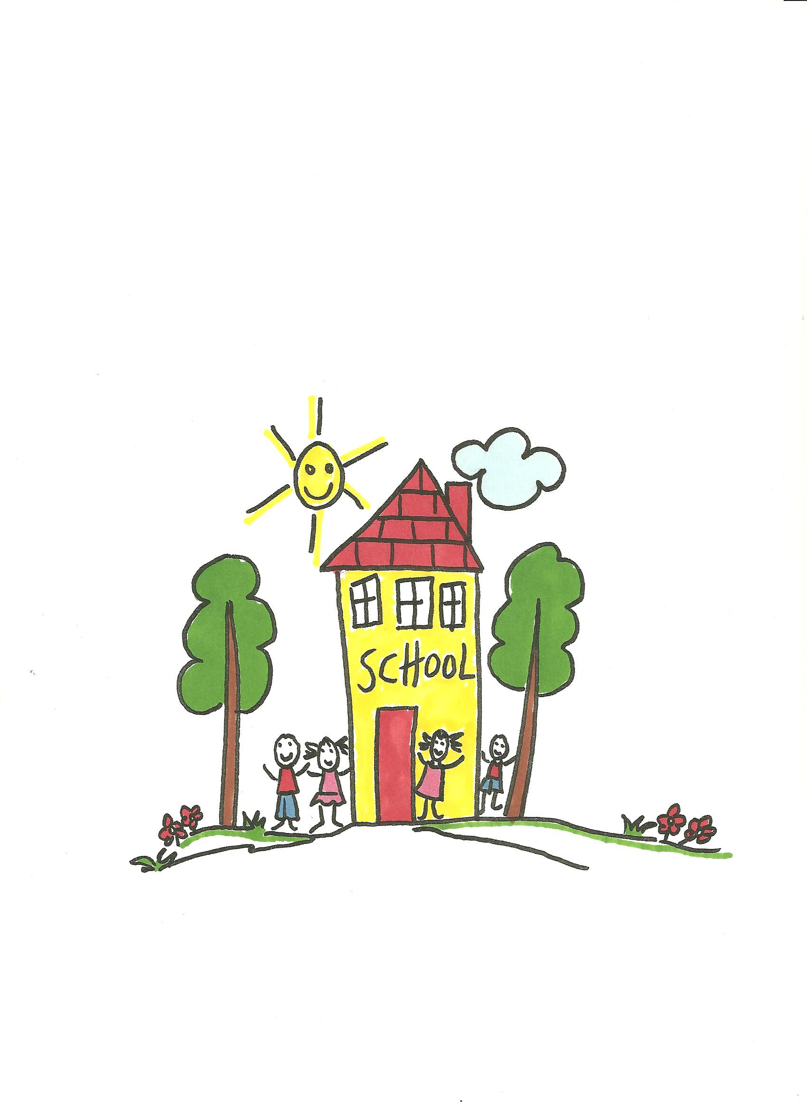

Preparing for New School
(Moving On)

Faith | - God is always with us and will be with you in your  new school
Values / Morality | - Appreciate everyone in nursery school
Points for  Discussion | - Growing and changing  - Look at and discuss photographs taken throughout the year  - New school:  - looking forward to the change  - concerns  - graduation
Prayers | - Jesus Grew Up Just Like Me
Sacred Space | - Cloth in colour of choice  - Candle  - Bible  - Selection of class photographs taken throughout  the year
Children's Bible Stories | Suggested links with scripture:  - The Boy Jesus : Luke 2
Songs & Nursery Rhymes | - When I Was a Baby  - The Seed Song  - One Candle  - I Come to School

Books | Mama, Don’t Go!  By Rosemary Wells, illustrations by Jody Wheeler  Published by Disney-Hyperion  ISBN-10: 0786807202  My First Day at School  By Erin Gathrid, illustrations by Ruth Wickings  Published by Golden Books  ISBN-10: 0307331032  Wemberly Worried  By Kevin Henkes  Published by Harper Collins  ISBN-10: 0061857769  I am Too Absolutely Small for School  By Lauren Child  Published by Orchard  ISBN-10: 1846168856
Links with Family | - Graduation Ceremony

Prayers

Jesus Grew Up Just Like Me
God made little babies
who grow up just like me.
He gave each a little nose
and eyes so they can see.
He made them grow and grow.
He made them grow and grow.
God is so wonderful,
we do love him so.

Songs and Nursery Rhymes

When I Was a Baby
Q. When I was a baby.
When I was a baby.
When I was a baby.
What could I do?

A. I could crawl and cry and smile,
I could crawl and cry and smile,
I could crawl and cry and smile;
that’s what I could do.

Q. Now I am at Nursery.
Now I am at Nursery.
Now I am at Nursery.
What can I do?

A. I can sing and paint and play.
I can sing and paint and play,
I can sing and paint and play;
that’s what I can do.

Q. When I am a school child.
When I am a school child.
When I am a school child.
What will I do?

A. I will read and write and pray,
I will read and write and pray,
I will read and write and pray;
that’s what I will do.

Q. When I am a grown-up.
When I am a grown-up.
When I am a grown-up.
What will I do?

A. I will do lots of different things,
I will do lots of different things,
I will do lots of different things;
so will you.

The Seed Song
Seeds are planted deep, deep, deep.
In the ground they sleep, sleep, sleep.

God sends sunshine bright, bright, bright.
Raindrops falling light, light, light.

Seeds are planted deep, deep, deep.
In the ground they sleep, sleep, sleep.

Gentle breezes blow, blow, blow.
Little seeds they grow, grow, grow.
Grow, grow, grow, grow.

One Candle
One candle on a birthday cake burning bright to show,
that today you’re one year old,
ready, steady, blow!

Two candles on a birthday cake burning bright to show,
that today you’re two years old,
ready, steady, blow!

Three candles on a birthday cake burning bright to show,
that today you’re three years old,
ready, steady, blow!

Four candles on a birthday cake burning bright to show,
that today you’re four years old,
ready, steady, blow!

I Come To School
I come to school each morning,
happy as can be,
my teacher’s always waiting
with a smile for me.
We sing our songs,
we play our games
we laugh and dance and play,
my teacher keeps me happy
in my nursery every day.

