SUMMER

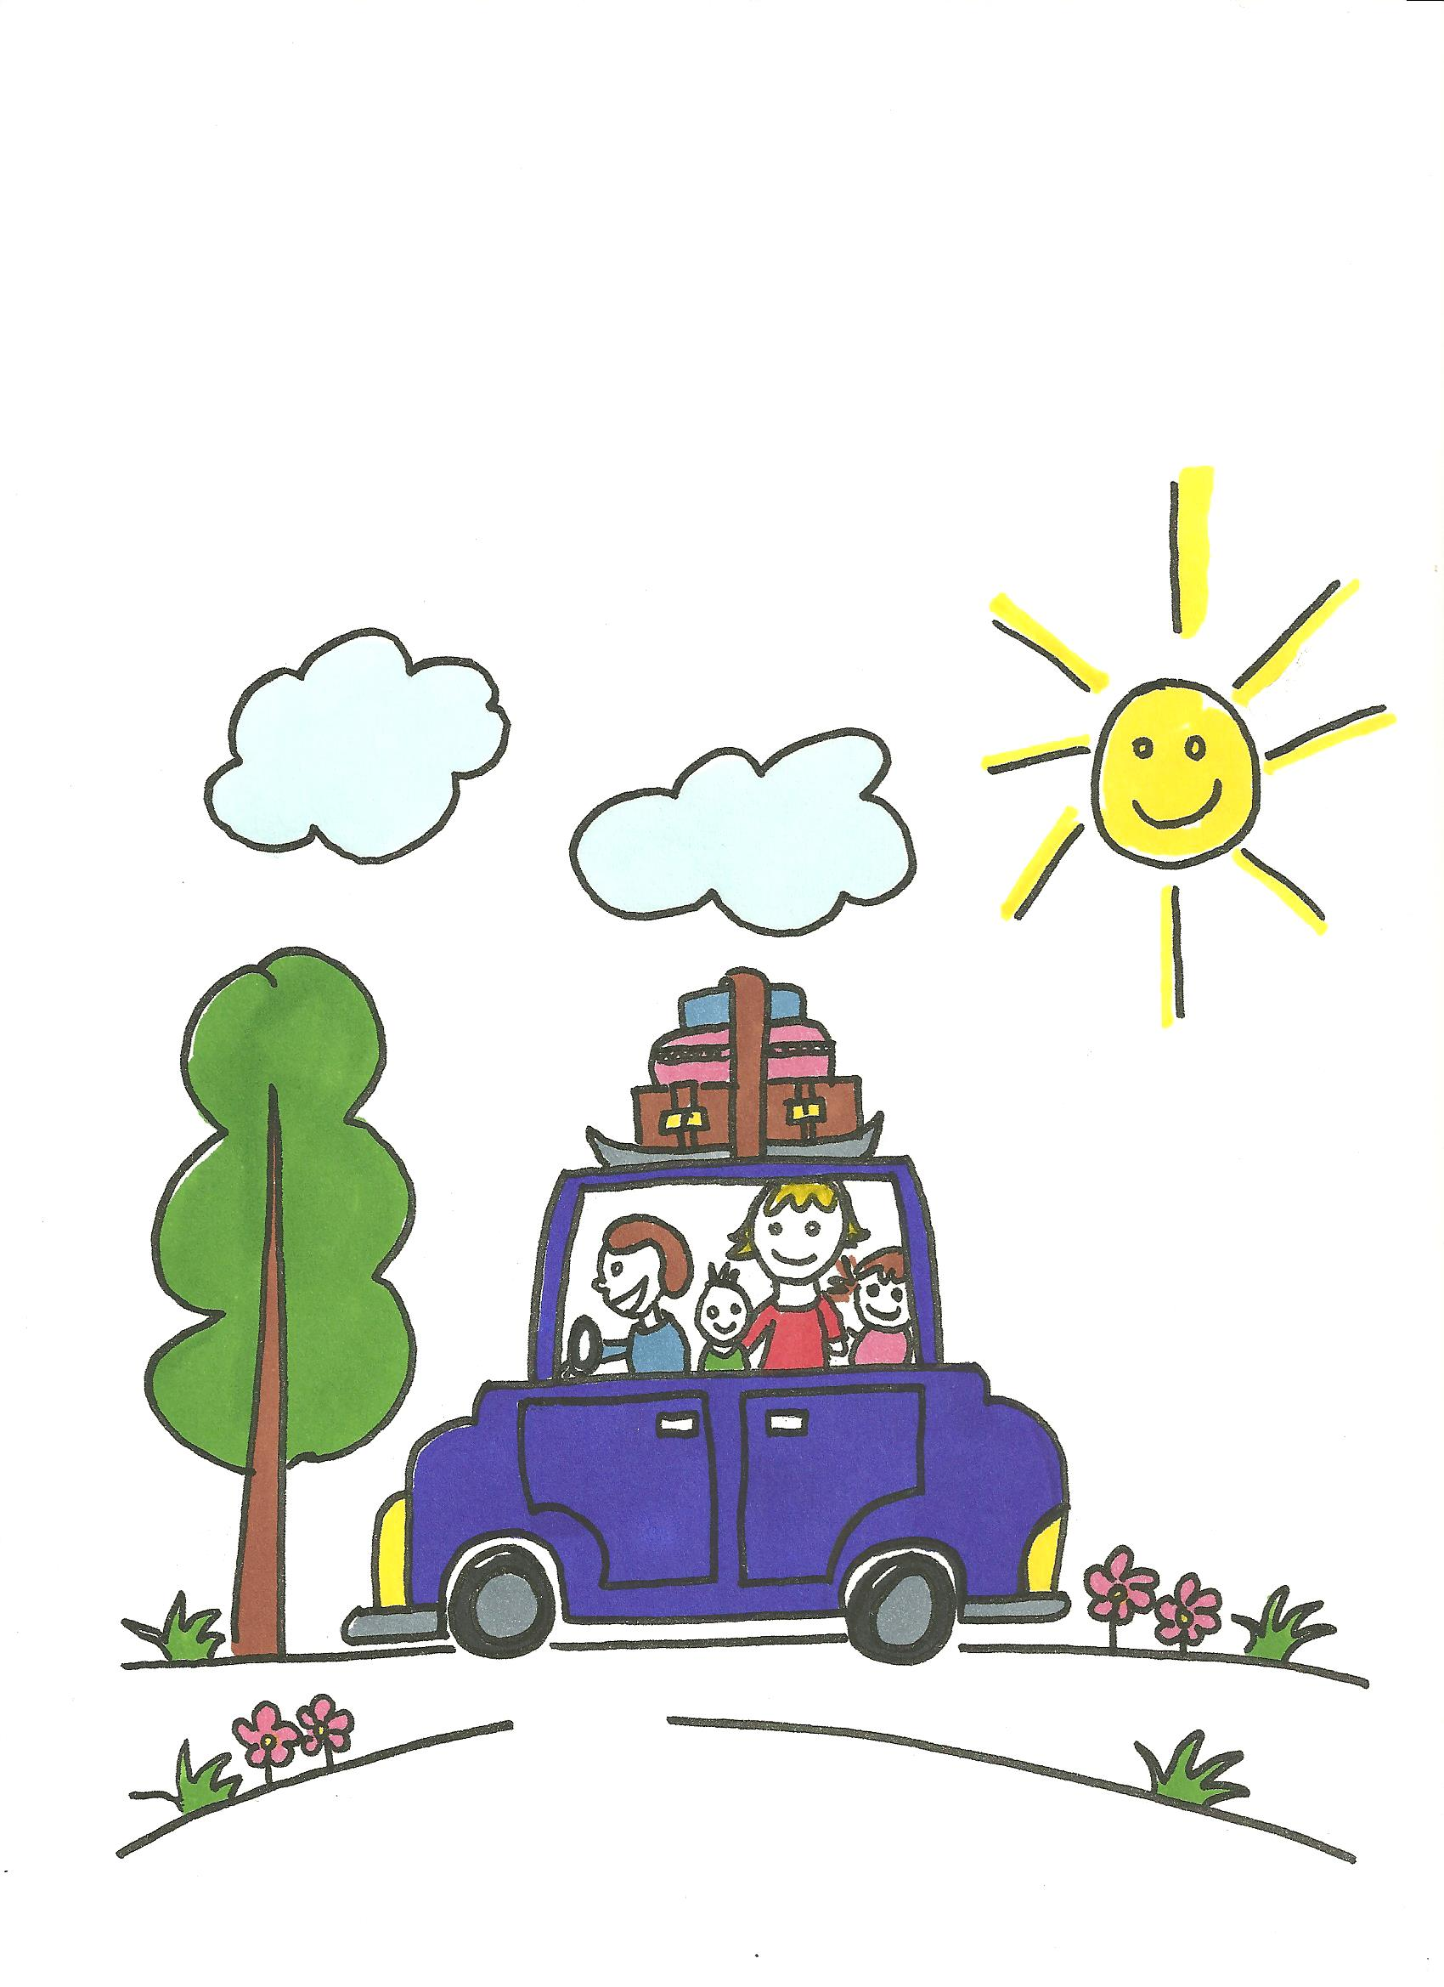

Summer - Holidays

Faith | - God made the world
Values / Morality | - Respect for the environment:  - at the sea-side  - at the park  - in the countryside
Points for  Discussion | - Seasonal changes  - Weather  - Things we do with our families – at home, on holiday  - Where we go on holidays  - New experiences when we go somewhere different
Prayers | - God made the Earth and God Made the Sky  - I see God in a Rainbow  - A Big Grey Elephant
Sacred Space | - Cloth of colour of choice  - Candle  - Children’s Bible  - Children’s pictures of summer  - Flowers, shells
Children's Bible Stories

Songs & Nursery Rhymes | - He’s Got The Whole World in His Hands  - God Made Butterflies

Books | Beach Day  By Karen Roosa, illustrations by Maggie Smith  Published by Clarion Books  ISBN-10: 0618029230  What Lives in a Shell?  By Kathleen Weidner Zoehfeld, illustrations by  Helen K Davies  Published by Harper Collins  ISBN-10: 0064451240  Commotion in the Ocean  By Giles Andreae, illustrations by David Wojtowycz  Published by Orchard  ISBN-10: 1408308452
Links with Family | - Staying safe with my family

Prayers

God Made the Earth and God Made the Sky
God made the earth and God made the sky.
God made the fishes and the birds that fly.
Animals, flowers, trees so tall,
God made everything big and small.
God made all that I can see,
God made the earth and God made me.

I See God in a Rainbow
I see God in a rainbow,
I see him in a sky of blue.
I see God in the moon and stars;
I see him in me and you.

Chorus ... I see him in Summer, in Winter, Autumn and Spring;
I see him, I see him;
I see him in everything.

I hear God in his music,
I hear him in the buzzing bee.
I hear God in the whispering wind;
I hear him in you and me.

Chorus ... I hear him in Summer, in Winter, Autumn and Spring;
I hear him, I hear him,
I hear him in everything.

A Big Grey Elephant
A big grey elephant.
A little yellow bee.
A tiny white daisy.
A tall green tree.
A red and white sailing boat
on a blue sea.
All these things you gave to me,
when you made me my eyes to see.
Thank you God.
Amen

Songs and Nursery Rhymes

He’s Got the Whole World in His Hands
He’s got the whole world in his hands;
he’s got the whole wide world in his hands;
he’s got the whole world in his hands;
he’s got the whole world in his hands.

Create your own verses ...

He’s got our family …
He’s got the mountains and the rivers …
He’s got the fish and the birds …

God Made Butterflies
God made butterflies,
God made bees,
God made flowers and God made trees.
Caterpillars, spiders, tiny bugs,
God made them all, yes even the slugs.
God made everything, look and see,
God made you and God made me.

