Down and Connor
Catholic Schools’ Support Service

The Woman at the Well

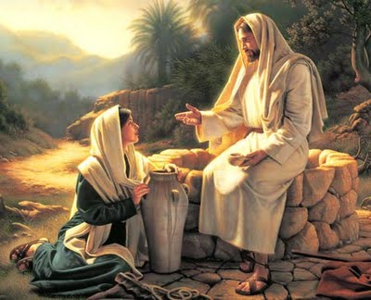

“I will guide you along the best pathway for your life.
I will advise and watch over you.”

Psalm 32:8-9

Welcome

Allow staff a few minutes to “settle down”.
Put everything down on the floor.
Sit comfortably.

Leader

Sign of the Cross
In the name of the Father
and of the Son
and of the Holy Spirit
Amen

Leader

Choose one person to read from the bible.
Read the passage slowly, allowing time for participants to picture the scene and hear the conversation between Jesus and the Samaritan woman.

A reading from the Gospel of St John 4:5-15; 25;

On the way he came to a Samaritan town called Sychar near the land that Jacob gave to his son Joseph. Jacob’s well was there and Jesus, tired by the journey, sat down by the well. It was about the sixth hour.

When a Samaritan woman came to draw water, Jesus said to her, “Give me something to drink.” His disciples had gone into town to buy food.

The woman said to him, “You are a Jew. How is it that you ask me, a Samaritan, for something to drink? – Jews, of course, do not associate with Samaritans.

Jesus replied to her:
“If only you knew what God is offering
and who it is that is saying to you,
‘Give me something to drink,’
you would have been the one to ask,
and he would have given you living water.’

“You have no bucket, sir,” she answered, and the well is deep: how do you get this living water? Are you a greater man than our father Jacob, who gave us this well and drank from it himself with his sons and his cattle?”

Jesus replied:
“Whoever drinks this water
will be thirsty again;
but no one who drinks the water
that I shall give
will ever be thirsty again:
the water that I shall give
will become a spring of water within,
welling up for eternal life.”

‘Sir,’ said the woman, ‘give me some of that water, so that I may never be thirsty or come here again to draw water.’

The woman said to him, ‘I know that Messiah – that is, Christ – is coming; and when he comes he will explain everything.’

Jesus said, ‘That is who I am, I who speak to you.’

Self-Reflection

Some ideas to help direct self-reflection. The idea is that staff have an opportunity for quiet, personal reflection and prayer. You may wish to play instrumental music for the self-reflection period.

Some thoughts to aid quiet reflection

- What does this Gospel passage say to me?

- What has drawn my attention or struck me in some way?

- Why? Was it a person, a word, a situation, a gesture?

- What is God saying to me through these words today?

Some thoughts on the passage for consideration

- We know the woman was a Samaritan, a race with whom Jews did not associate.

- Women, at that time, typically drew water in groups in the morning. It was often a social occasion. The fact this woman was drawing water alone, at midday, might indicate she was considered marginalised from society.
How do you interact with people society marginalises? Do you avoid them? Why?

- From her conversation with Jesus we can see she was very curious and felt comfortable enough not only to talk to him but to ask him questions.
What would I ask Jesus if I met him like the Samaritan woman?

- Jesus revealed much about himself – he was the Son of God, the Messiah and he had come to offer living water to all. Water is the elixir of life. How can I live a life that enriches others?

- The woman and Jesus are equal partners in the conversation indicating Jesus’ love for all people and clearly showing us all are welcome in God’s Kingdom.

Concluding Prayer

Lord, let me do your will;
make your way plain for me to follow. (Psalm 5)
Like the woman at the well,
I am seeking
to know your ways more clearly.
Help me discern your path for me
and know your love in my life.
Watch over me and guide me.
Amen

