Down and Connor
Catholic Schools’ Support Service

The Praying Hands

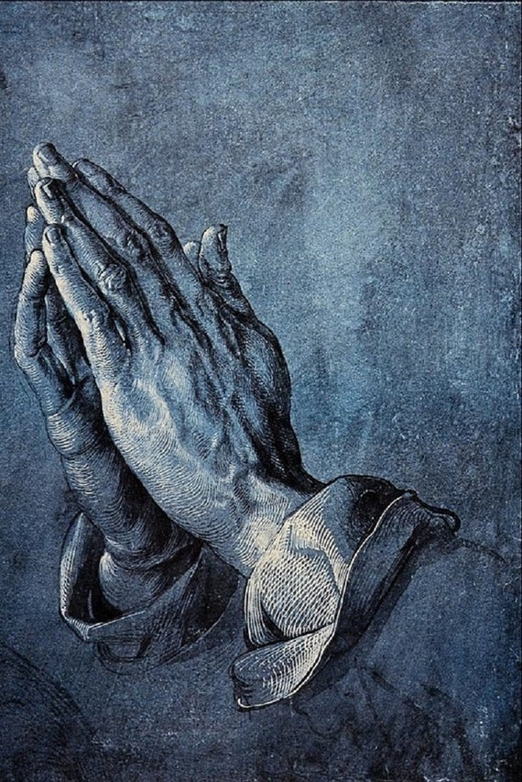

Lord
Be my friend this day.
Help me to live as best I can.
Guide my steps along the way
And keep me always in your hand.

St Therese

Welcome

Welcome staff and share the following story with them. Perhaps display the front cover/picture.

Leader

Sign of the Cross
In the name of the Father
and of the Son
and of the Holy Spirit
Amen

Opening Prayer
Lord,
be my friend this day.
Help me to live as best I can.
Guide my steps along the way
and keep me always in your hand.
Amen

Leader

Choose one person to read the story:

Praying hands, also known as Study of the Hands of an Apostle, is a pen-and-ink drawing by the German printmaker, painter and theorist Albrecht Dürer. The work is today stored at the Albertina Museum in Vienna, Austria. The story of the drawing may differ, whether two friends or two brothers but the message is the same.

During the fifteenth century two young friends, Albrecht Dürer and Franz Knigstein were struggling young artists. Since both were poor, they worked to support themselves while they studied art.

Work took so much of their time and advancement in art was slow. Finally they reached an agreement - they would draw lots, and one of them would work to support both of them while the other would study art. Albrecht won and began to study, while Franz worked at hard labour to support them. They agreed that when Albrecht was successful he would support Franz who would then study art.

Albrecht travelled the cities of Europe studying art. As the world now knows, he had not only talent but genius. When he had attained success, he returned home to keep his agreement with Franz. But Albrecht soon discovered the enormous price his friend had paid. For as Franz worked at hard manual labour to support his friend, his fingers had become stiff and twisted. His slender, sensitive hands had been ruined for life. He could no longer execute the delicate brush strokes necessary for fine painting. Though his artistic dreams could never be realised, he was not embittered but rather rejoiced in his friend’s success.
One day Albrecht came across his friend unexpectedly and found him kneeling with his gnarled hands entwined in prayer, quietly praying for the success of his friend although he himself could no longer be an artist. Albrecht Dürer the great genius hurriedly sketched the joined hands of his faithful friend and later completed a truly great masterpiece known as, “The Praying Hands”.

Today art galleries all around the world feature Albrecht Dürer’s works, and this particular masterpiece tells an eloquent story of love, sacrifice, labour and gratitude. It has reminded many people around the world how they may find comfort, courage and strength.

Author Unknown
Some thoughts to aid quiet reflection

- I invite you to look at the picture of the praying hands. Take some time to think of all the things your hands have done today or in the past few days. Thank God for the gift of your hands and all the ways in which you have shown his love to the people at home and in school.

- Take a few moments to silently ponder what you can do to bring you closer to God and others at this time.

- Think about the sacrifices others have made so you can pursue your vocation to work with children. Have I thanked those people? How can I show my appreciation to them?

You might wish to ask some members of staff to read this poem:

The Praying Hands

The “Praying Hands” are much, much more than just a work of art,
they are the “soul’s creations” of a deeply thankful heart.
They are a Priceless Masterpiece that love alone could paint,
and they reveal the selflessness of an unheralded saint.

These hands so scarred and toilworn, tell the story of a man
who sacrificed his talent in accordance with God’s Plan.
For in God’s Plan are many things man cannot understand,
but we must trust God’s judgement and be guided by his hand –

Sometimes He asks us to give up our dreams of happiness,
sometimes we must forgo our hopes of fortune and success –
Not all of us can triumph or rise to heights of fame,
and many times What Should Be Ours, goes to another name –

But he who makes a sacrifice, so another may succeed,
is indeed a true disciple of our blessed Saviour’s creed –
For when we “give ourselves away” in sacrifice and love,
we are “laying up rich treasures” in God’s Kingdom up above –

And hidden in gnarled, toilworn hands in the truest Art of Living,
achieved alone by those who’ve learned the “Victory of Giving”.
For any sacrifice on earth, made in the dear Lord’s name
assures the giver of a place in Heaven’s Hall of Fame.

And who can say with certainty where the greatest talent lies,
or who will be the greatest in our Heavenly Father’s eyes!

Helen Steiner Rice

Concluding Prayers

We pray today that we will be filled with the Holy Spirit, that our hearts will be renewed, our vision clarified in love and our hands ready to serve others, and so we pray …

O God, grant that we may be sensitive to your presence in our lives by taking time to pause for reflection and prayer each day.
Lord hear us

We pray that all staff and pupils of our school will grow in love and concern for those in need in our local communities.
Lord hear us

We pray that the leaders of our world will turn away from aggression and war and do all in their power to preserve peace.
Lord hear us

We pray that we may all use the resources of the earth wisely.
Lord hear us

Strengthen our inner resolve with your power that we may grow in gentleness when our lives are confronted with difficulties.
Lord hear us

We ask these, and all our prayers, through Christ Our Lord
Amen

Suggested Music
May the Lord Bless You and Keep You, Bernard Sexton
You Open Wide Your Hand, Ephrem Feeley
Christ Has No Body But Yours, David Ogden

