Down and Connor
Catholic Schools’ Support Service

Mercy - The Prodigal Son

“God’s mercy embraces those who have disobeyed and those who have been disappointed. In the parable of the Prodigal Son we are invited to look at both brothers to see how they stand before God in need of mercy, grace and salvation.”

Pope Francis

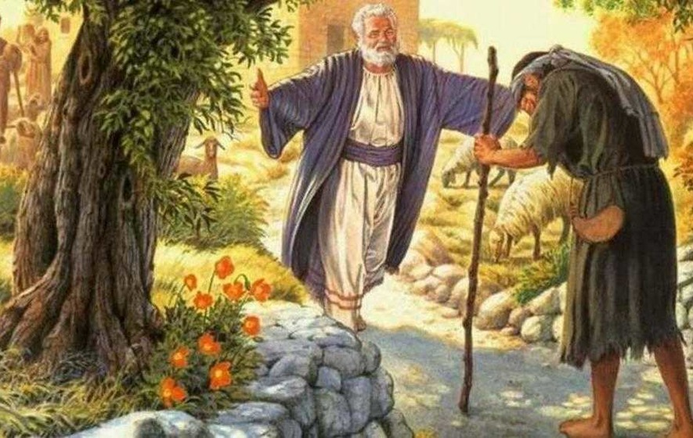

“ Teach me to be generous,
to give and not to count the cost.
To toil and not to seek for rest.
To labour and seek no reward,
save of knowing I do your will ……
Pray as if everything depended on God
and work as if everything depended on you.”

Prayer of St Ignatius

Welcome

Allow staff a few minutes to “settle down”.
Put everything down on the floor.
Sit comfortably.

Leader

Sign of the Cross
In the name of the Father
and of the Son
and of the Holy Spirit
Amen

Leader

Choose one person to read from the bible.
Read the passage slowly, allowing time for reflection.

A reading from the Gospel of Luke 15:25-31
Now his elder son was in the field; and when he came and approached the house, he heard music and dancing. He called one of the servants and asked what was going on. The servant replied, “Your brother has returned, and your father has killed the fatted calf, because he got him back safe and sound.”

Then the brother became angry and refused to go in. His father came out and began to plead with him. But he answered his father, “Listen! For all these years I have been working like a slave for you, and I have never disobeyed your command; yet you have never given me even a young goat so that I might celebrate with my friends. But when this son of yours comes back, who has devoured your property with prostitutes, you killed the fatted calf for him!”

Then the father said to him, “Son you are always with me, and all that is mine is yours. But we had to celebrate and rejoice, because this brother of yours was dead and has come to life; he was lost and has been found.”

Self-Reflection

Some ideas to help direct self-reflection. The idea is that staff have an opportunity for quiet, personal reflection and prayer. You may wish to play instrumental music for the self-reflection period.

The parable of the prodigal son is well known. People have commented on it, painted it and used it as an example of God’s mercy. Today we have listened to the second part of the parable.

The picture used on the front cover is of the father running with outstretched arms to meet his returning son. Parents, especially can relate to this image. No matter what a son or daughter has done to their family, the image of the father running – arms wide open in forgiveness – towards his wayward son is an image that resonates. Parents’ hearts have been broken, families destroyed, but the love of a mother or father is greater than all the brokenness.

Despite the behaviour of those close to us, we continue to love them. God’s compassion is immense. Our sense of despair in life can be offset by the merciful father running towards us to salve our sense of loss.

During this day an opportunity might arise to offer forgiveness or ask for mercy. The challenge is not to let it go another day.

Be merciful today and run towards forgiveness.

Some thoughts to aid quiet reflection:

- Consider seeking forgiveness for something in your life – God’s mercy is immense.

- Try to offer compassion to the people you meet today, without judgement or conditions.

Concluding Prayer

Ever faithful father,
You sent into the darkness of our lives your Son Jesus Christ, the light of the world.
Stretch forth your arms to embrace us, your sons and daughters.
Grant us serenity of mind and peace of heart.
Deliver us from all evil.
May God the Father bless us.
May God the Son comfort us.
May God the Holy Spirit enlighten us.
We make our prayer through Jesus Christ, our Lord.
Amen

Suggested Music

Shepherd Song, Bernard Sexton

