Down and Connor
Catholic Schools’ Support Service

“Knock and the door will be opened”

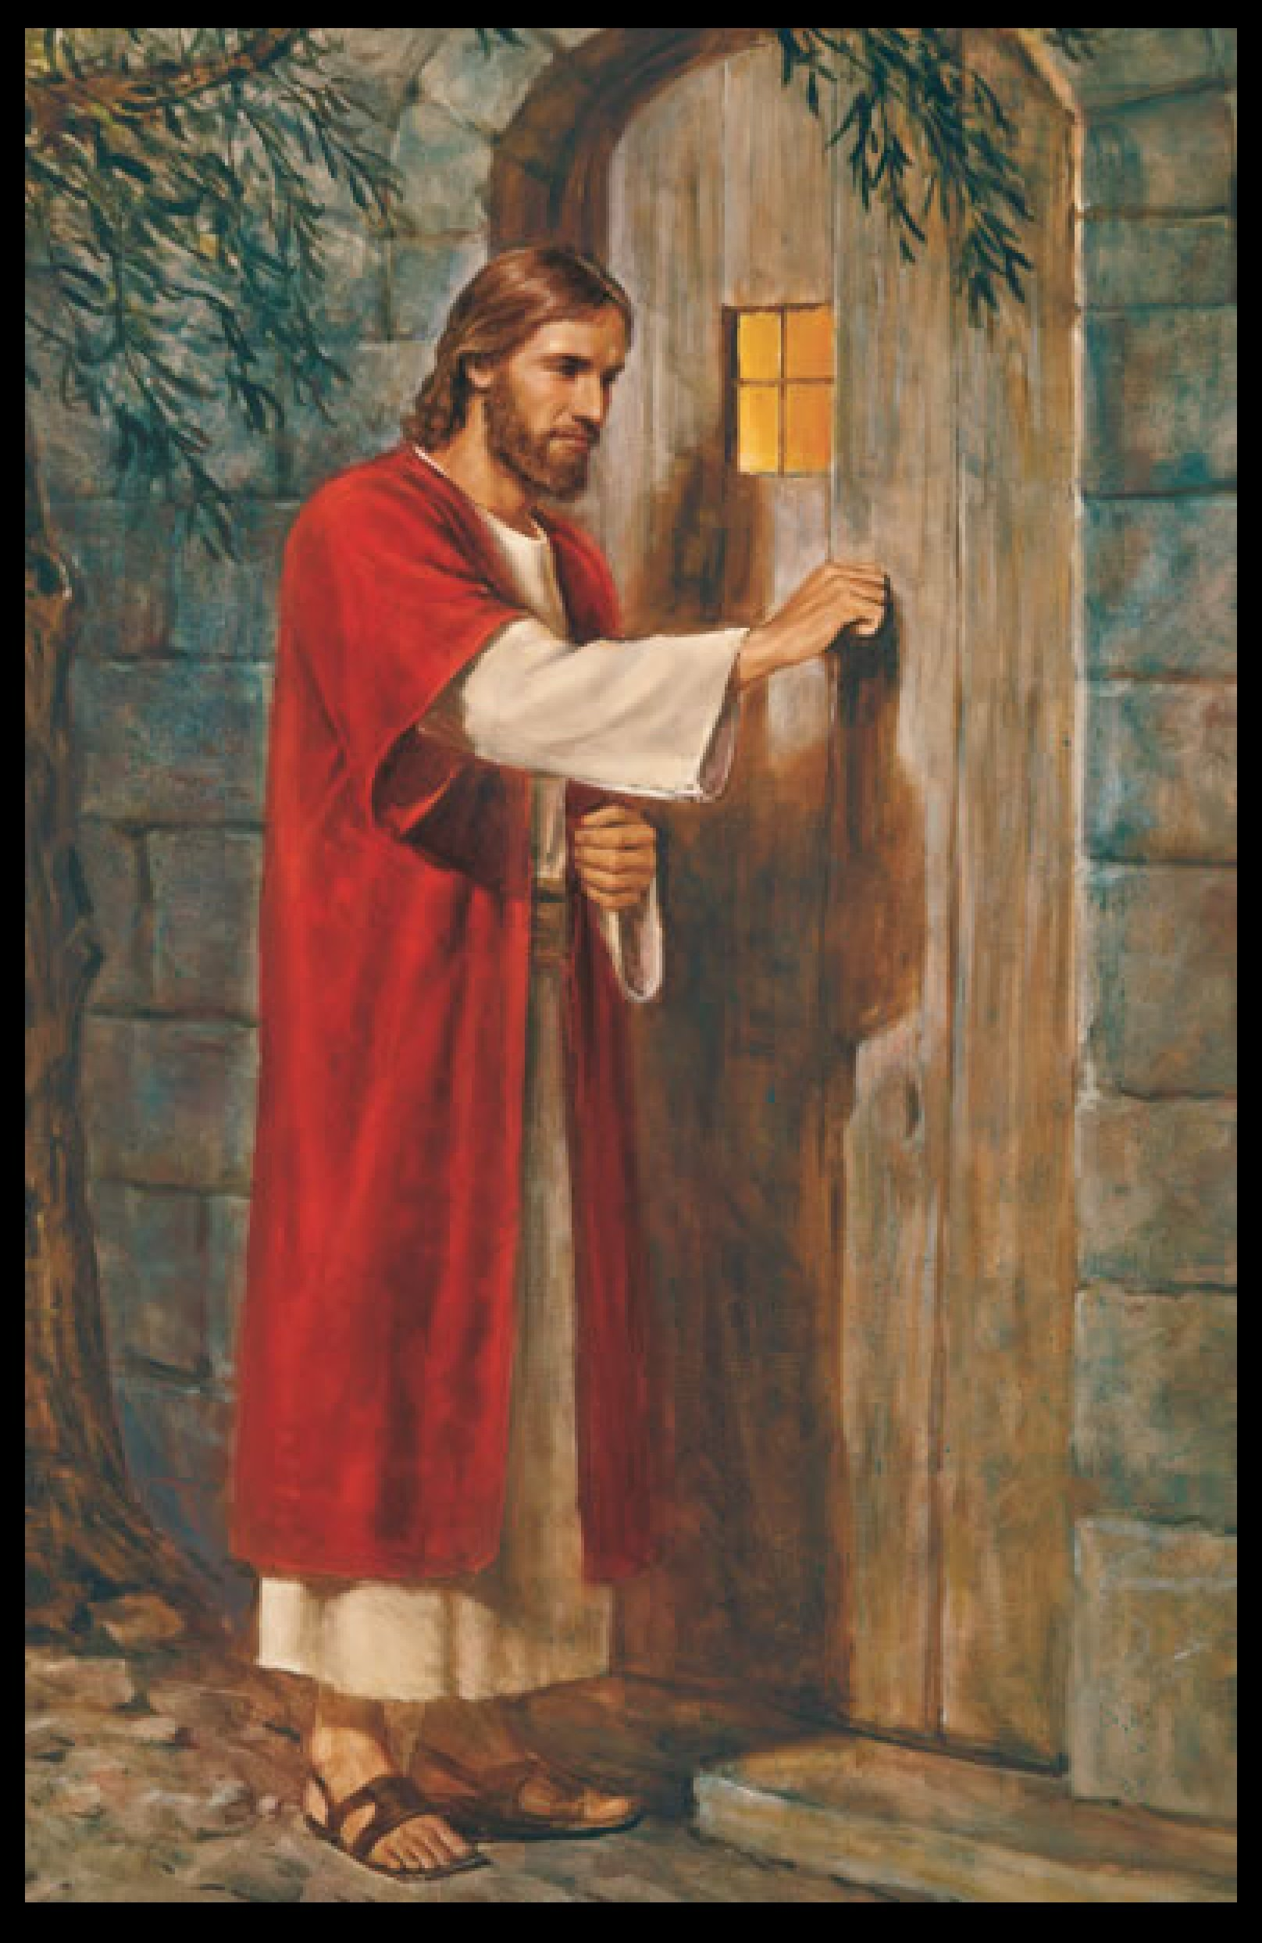

Welcome

Allow staff a few minutes to “settle down”.
Put everything down on the floor.
Sit comfortably.

Leader

Sign of the Cross (as a candle is lit)
In the name of the Father
and of the Son
and of the Holy Spirit
Amen

Leader

Display the picture on a large screen/whiteboard.
Allow staff time to look at the painting.

Open discussion by asking staff to share their thoughts on what they see. One of the most important things to note is the missing door handle on the outside of the door.

This painting is based on “The Light of the World” which was painted in the late nineteenth century by William Holman Hunt. There are many interpretations following in Hunt’s tradition; this painting is one of them.

Choose one person to read from the bible.
Read the short passage slowly, allowing time for reflection.

A reading from the Book of Revelation 3:20
Look, I am standing at the door, knocking.
If one of you hears me calling and opens the door, I will come in to share a meal at that person’s side.

What does this passage say to you today?

- Jesus is depicted knocking at a door with no handle on the outside. It is up to the person on the other side of the door to let Jesus in.
How often do I hear Jesus knocking?
How often do I let him in?

- Jesus will not force his way in, we must open our hearts to him from within.

- Knock and the door will be opened is our invitation to Jesus.

Concluding Prayer

Lord Jesus
I pray that when I hear your knock on the door
I am ready to open my heart to your call.
Grant me a listening ear,
a welcoming smile,
and a heart ready to do your will.
Amen

Suggested Music

The Shepherd Song, Bernard Sexton

Be Thou My Vision

Peace I Leave With You

Do Not Be Afraid

