Down and Connor
Catholic Schools’ Support Service

“Courage! It is I!
Do not be afraid.”

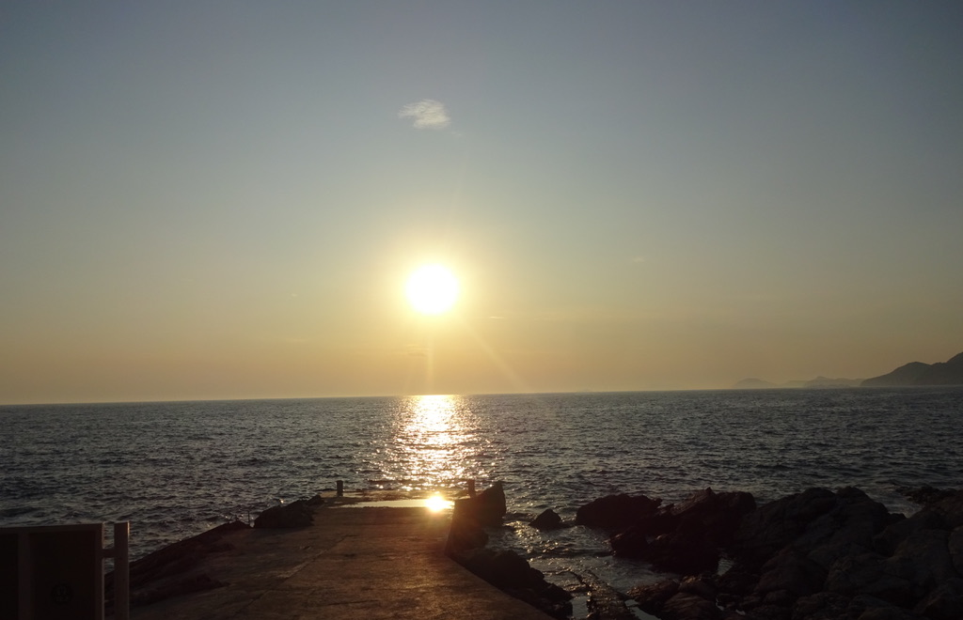

“The moment we cease to hold each other,
the moment we break faith with one another,
the sea engulfs us and the light goes out.”

James Baldwin

Welcome

Allow staff a few minutes to “settle down”.
Put everything down on the floor.
Sit comfortably.

Leader (as you light a candle)

Sign of the Cross
In the name of the Father
and of the Son
and of the Holy Spirit
Amen

Leader

Choose one person to read from the bible.
Read the passage slowly allowing time for the listeners to hear the word of God.

A reading from the Gospel of St Matthew 14:22-33
(The story of Jesus walking on the water)
And at once he made the disciples get into the boat and go on ahead to the other side while he sent the crowds away. After sending the crowds away he went up into the hills by himself to pray. When evening came, he was there alone, while the boat, by now some furlongs from land, was hard pressed by rough waves, for there was a headwind. In the fourth watch of the night he came towards them, walking on the sea, and when the disciples saw him walking on the sea they were terrified. ‘It is a ghost,’ they said, and cried out in fear. But at once Jesus called out to them, saying, ‘Courage! It is me! Don’t be afraid! It was Peter who answered. ‘Lord’, he said ‘if it is you, tell me to come across the water.’ Jesus said, ‘Come.’ Then Peter got out of the boat and started walking across the water, but then noticing the wind, he took fright and began to sink. ‘Lord,’ he cried, ‘save me!’ Jesus put out his hand at once and held him. ‘You have so little faith,’ he said, ‘why did you doubt?’ And as they got into the boat the wind dropped. The men in the boat bowed down before him and sad, ‘Truly, you are the Son of God.’
The New Jerusalem Bible

Self-Reflection

Some ideas to help direct self-reflection. You may wish to use all of these ideas, a selection or just one to focus on. The idea is that staff have an opportunity for quiet, personal reflection and prayer. You may wish to play instrumental music for the self-reflection period.

- The first action of Jesus is to send the disciples and the crowds away so he can go up to the hills by himself and pray. Jesus went away by himself.
How many times do I get a chance to take time by myself?
What do I do?

- Think about how many times you have wanted to walk to the other side, just to get away from things.
Why did you want to get away from things? Did you turn to Jesus to help you?
- We have listened to the familiar story of the disciples in the boat, far out on the lake. Sometimes Jesus comes to us in circumstances we least expect to find him.
How do we react?

- Invite staff to take a few minutes to focus on Jesus walking on the water.
For the disciples the sea was a hostile element. Jesus’ walking on the water is symbolic of His power. Jesus told his disciples not to be afraid.
Do I listen to those words of Jesus?
Or do I try to manage everything myself?

- Sometimes we might focus on the power of Jesus to control the wind and waves and to walk on water. Maybe give some thought to the transformative quality of Jesus. He doesn’t over-power the elements; he changes them.
How can Jesus transform my life?

- It was significant that when the disciples saw Jesus they were terrified, thinking He was a ghost. What might make them respond like that?

- Let us focus on the incident with Peter at the end of the account. Take some time to either focus on Jesus as leader or guide or on St Peter as a model of ourselves when we take a bold step and then, once we have stepped out, are afraid.

Concluding Prayer

Lord, we are all leaders like Jesus.
We know that a time comes when we must be alone.
We know we all need time set aside to pray.
But we are often like the disciples on a boat far from any shore,
battling with a heavy sea and facing a headwind.

(Pause)

Lord, prayer is experiencing that you are really with us.
Of feeling afraid and knowing you have put out your hand and held us.
Thank you, Lord.
Be our model and guide in our work
and help us to put out our hands to hold each other and the pupils in our care.
We ask this through Our Lord Jesus Christ.
Amen

Suggested Music

Guard Us Lord, Ephrem Feeley

Be Not Afraid, Bob Dufford, SJ

Be Not Afraid, Stephen Petrunak

I Will Be With You, Stephen Petrunak

Do Not Be Afraid, Bernard Sexton

