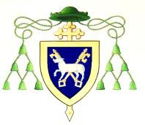

DOWN and CONNOR DIOCESAN TRUST
PARISH SECRETARY – PART TIME COLERAINE PARISH
A vacancy has arisen for a Parish Secretary within Coleraine Parish, 72 Nursery Avenue, Coleraine BT52 1LR.

The post holder will be required to:

- provide confidential, efficient and effective secretarial support to the Parish Priest, and assistance to visitors and parishioners who visit or make contact with the Parish office;
- effectively and efficiently assist in the management and maintenance of the Parish Office.

The terms are based on a permanent appointment requiring 20 hours per week, Monday – Friday 9.00am – 1.00pm.

Rate of Pay - £10.50 gross per hour.

Full details relating to the vacancy can be found on the Diocesan website at: http://www.downandconnor.org clicking on the tab: JOB VACANCIES and on the Community NI website, where terms and conditions relating to the role can also be accessed by way of a Role Profile and Employment Application form. Application packs can also be obtained from Coleraine Parish Office.

We welcome applications from anyone who feels they meet the criteria and are interested in playing an active part in the Parish.

Closing date for applications will be 12.00 noon on Friday 16th April 2021

Down and Connor Diocesan Trust is an Equal Opportunities Employer

