Issue 53
June 2019

Sharing the Good News

Newsletter for Parishes and Dioceses |www.catholicbishops.ie
published by Catholic Communications Office, Maynooth, Co Kildare

World Communications Day 2019 marked in Maynooth with seminar on ‘Believers in the Digital World’

More than 50 people from across the country attended a half-day seminar in St Patrick’s College Maynooth on 29 May to mark World Communications Day 2019. The seminar, which was chaired by Senator Joan Freeman, was entitled ‘Believers in the Digital World: Opportunities for Mission’. Archbishop Eamon Martin, Chair of the Bishops’ Council for Communications, delivered the opening address.The seminar also heard contributions by faith representatives and digital experts as well as video input from students of Saint Peter’s College, Dunboyne, on the influence of social media in their lives. Brenda Drumm of the Catholic Communications Office focused on faith and evangelisation in the digital space, while Emma Tobin and Oisín Walsh reflected on the digital media experience of, and environment for, young people.
The seminar also considered some of the more challenging aspects of the digital world with Detective Sergeant Mary McCormack speaking about the extent of the challenge to society of online abuse and how to respond and Darren Butler of the Bishops’ Pastoral Response to Subsistence Misuse on the role of parishes in addressing internet addiction. You can read more about the seminar on www.catholicbishops.ie.

Irish vocation directors offer support to young people
Representatives from the Irish National Vocations Office and Vocations Ireland recently attended the ‘Congress for the Pastoral Care of Vocations in Europe’ in Rome. The focus of the meeting was to address the final document of the Synod on Young People, the Faith and Vocational Discernment, and incorporate its message into vocations promotion in the context of Europe.
Speaking at the conclusion of the congress, Father Willie Purcell of the National Vocations Office said: “In Ireland we wish to help young people realise that each one of them has a unique calling from Christ, and we aim to support them in answering that call, particularly in the case of those who are discerning vocations to the priesthood or religious life.” For more see www.vocations.ie.

NEWS IN PICTURES
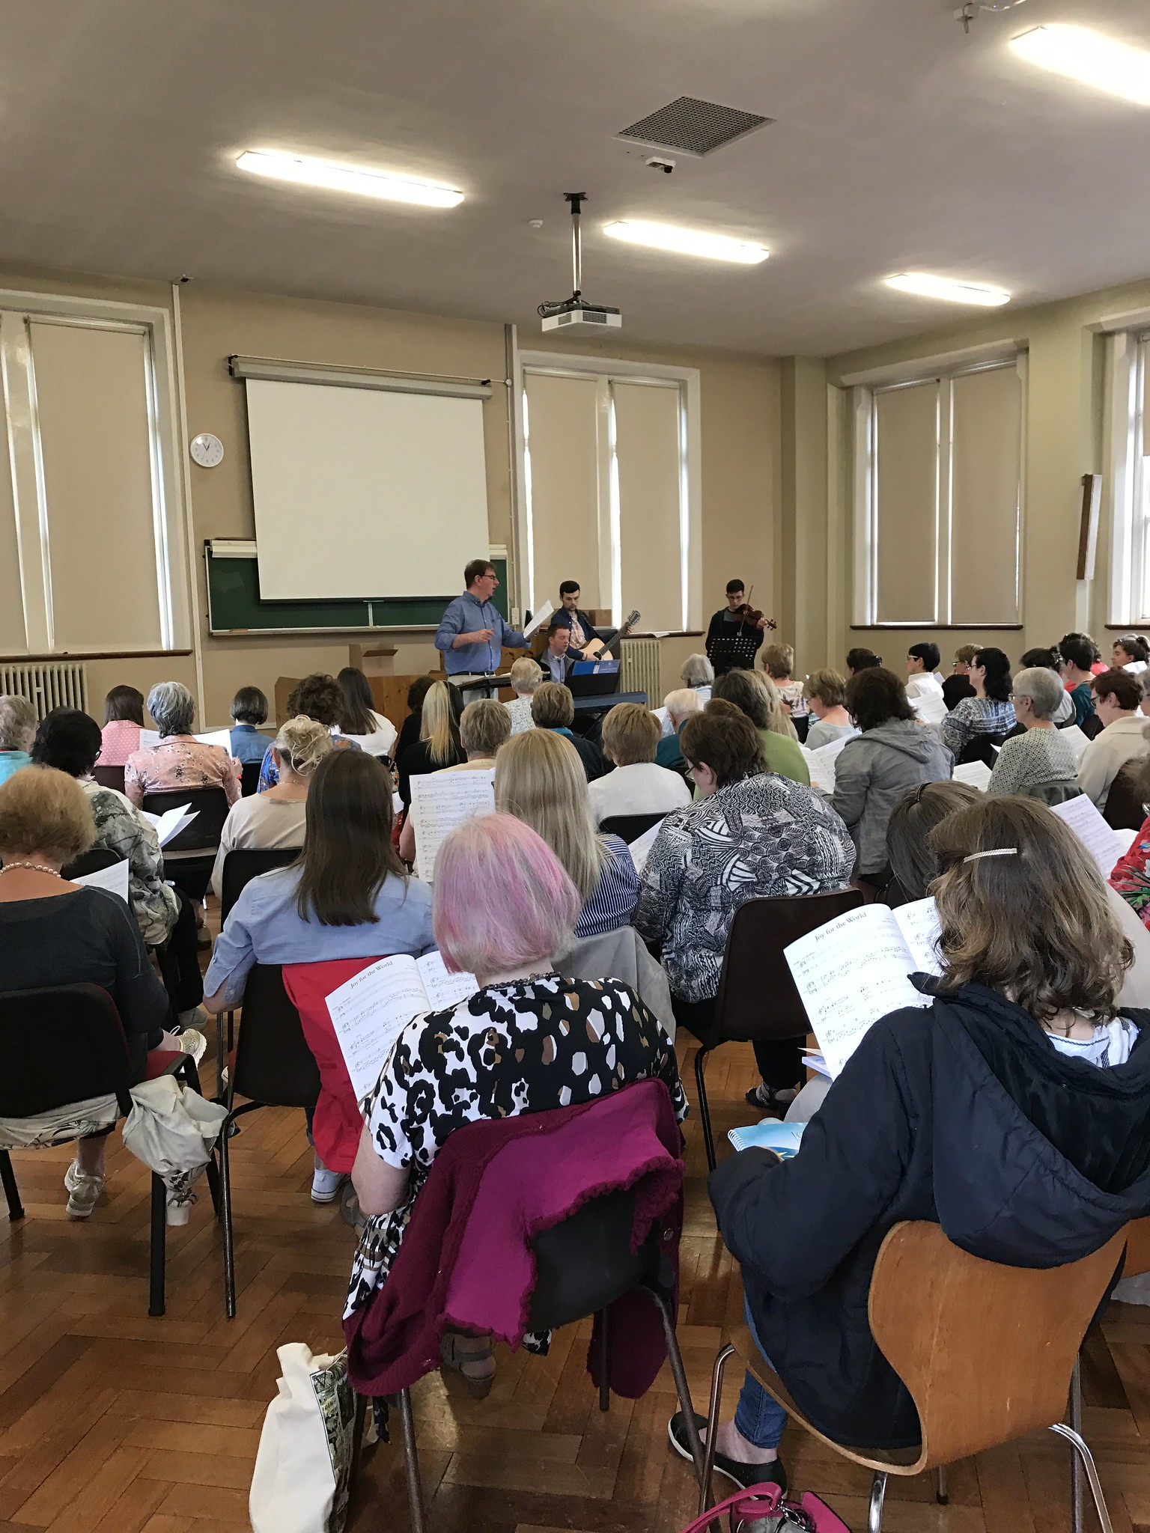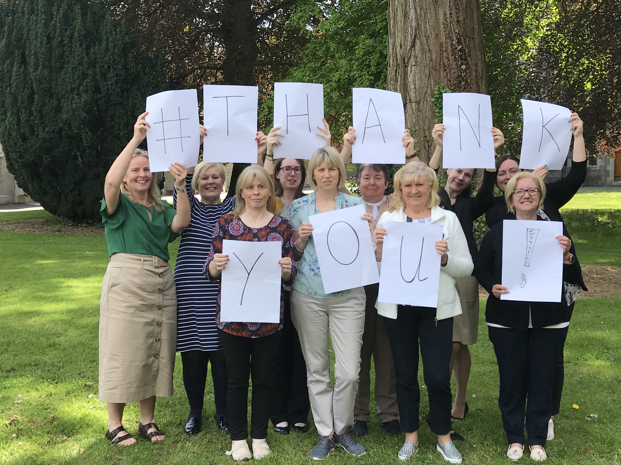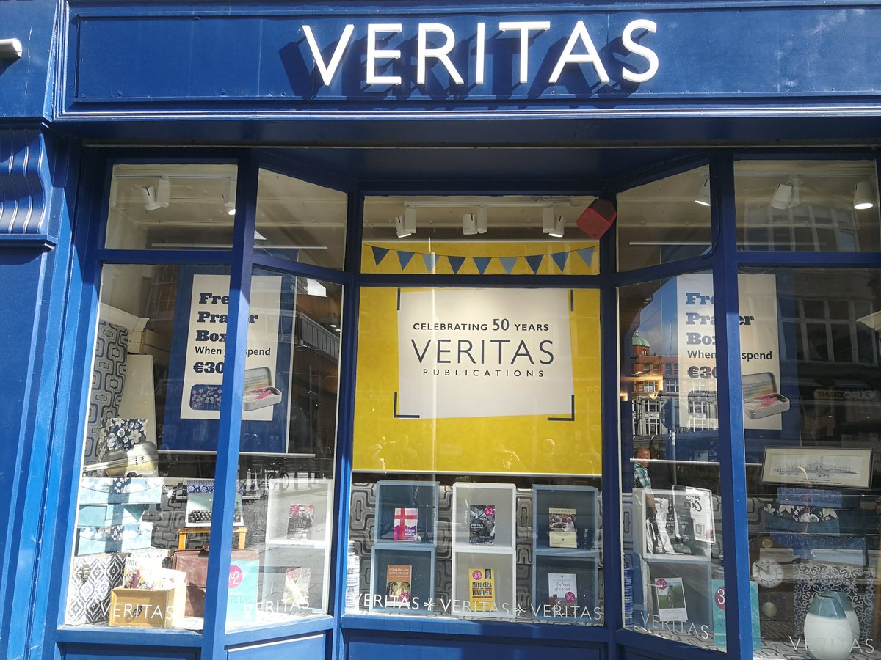
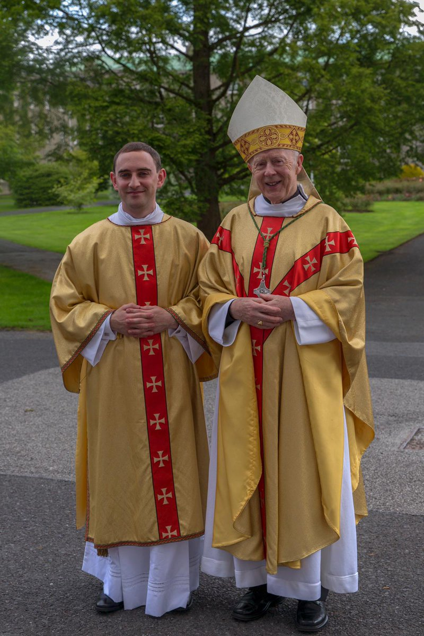
Archbishop Michael Neary of Tuam pictured with Rev Shane Costello on the occasion of his ordination to the diaconate on 2 June.

Captions:
2019 marks Veritas’ 50th year in publishing. Their first ever title was Patrick In His Own Words by Bishop Joseph Duffy, Bishop Emeritus of Clogher Diocese, which has been reprinted to mark the anniversary. See www.veritas.ie.

The Irish Church Music Association Summer School will take place from 2 – 5 July in Saint Patrick’s College, Maynooth, marking 50 years of the association in Ireland. For details of this year’s event and to make a booking see www.irishchurchmusicassocation.com .

Staff from Accord Catholic Marriage Care Service saying THANK YOU to all their volunteers during National Volunteering Week 2019.

Archbishop Michael Neary of Tuam pictured with Rev Shane Costello on the occasion of his ordination to the diaconate on 2 June.

There was incredible energy at the final of the Trócaire Game Changers Competition which took place recentlythe Helix in DCU, Dublin. Giant dice were being thrown, cards were being dealt, and tablets were being tapped. Trócaire Game Changers is a competition for young people who want to change the world and believe games are a way to do this. Pictured here are the winners in the youth category David O’Dwyer and Tom Laffey from Youth Work Ireland Tipperary - Cashel Neighbourhood Youth Project with their game ‘SDGs and me’.

Archbishop Diarmuid Martin of Dublin, has expressed his concern over the violence of drug cartels in Dublin in recent weeks. He said, “In the past weeks, this violence has taken on an unprecedented level of depravity with shootings taking place unscrupulously near schools and shopping centres, leaving families terrified and children witnessing brutality that will leave scars on their lives for years. The perpetrators and sponsors of such violence merit nothing but rejection and distain.” Read the statement in full on www.dublindiocese.ie.

Summer General Meeting of Bishops concludes in Maynooth
The Summer General Meeting of the Irish Catholic Bishops’ Conference concluded on Wednesday 12 June in the Columba Centre, Saint Patrick’s College, Maynooth. Issues discussed by the bishops during their meeting included: Christian response to religious intolerance, racism and bigotry; Relationships and sexuality education; Safeguarding children; Government’s structured dialogue meeting on 4 July; World Communications Day 2019; Catholic Schools Week 2020 dates and theme; Bishops’ Conference membership and In Memoriam.
You can read the statement on catholicbishops.ie.

Published by the Catholic Communications Office of the Irish Catholic Bishops’ Conference which can be contacted on info@catholicbishops.ie

