Primary Pupil Survey
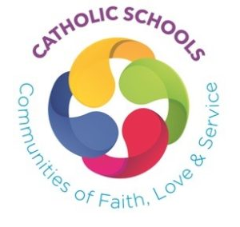
Please tick a box to show how old you are:

√
6 years old or younger
7 or 8 years old
9 years old or older

Please tick your answer to each question |  | Yes | Mostly | Sometimes | No
1. | I feel happy and safe in school.
2. | The people in our school try to live out our Mission Statement.
3. | In school I am getting to know God better.
4. | I am given opportunities to deepen my relationship with God.
5. | I feel I am listened to by my teachers.
6. | I feel valued in my school.
7. | Worshipping together helps me to understand more about my Catholic faith.
8. | In school I am helped to reflect on how I should treat other people.
9. | I take pride in my work in RE.
10. | I have opportunities to share my thoughts, feelings and worries.
11. | In school I am taught about and helped to understand and respect the faiths of other people.
12. | I am encouraged to make up and share my own prayer.
13. | I am given opportunities to take part and lead liturgies.
14. | In school I am learning how to live like Jesus and be a better person.

Do you want to say anything else about your school?
Please write it here BUT DO NOT WRITE DOWN THE NAMES OF TEACHERS OR OTHER ADULTS.

Signature: Date:
(Optional)

