Post Primary Pupil Survey
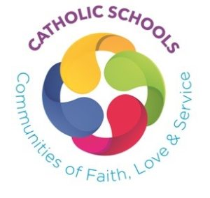
Please tick a box to show what Key Stage you are in:

√
Key Stage 3
Key Stage 4
Key Stage 5

Please tick your answer to each question |  | Yes | Mostly | Sometimes | No
1. | I feel welcome safe and valued in my school.
2. | In school I am supported in the development of my relationship with God.
3. | I am given opportunities to participate in activities that assist me in living as a follower of Christ.
4. | In this school the student voice is respected.
5. | The school community celebrates Mass together.
6. | I am encouraged to lead acts of worship within school and in my parish community.
7. | As part of the school community I am able to mark and celebrate the feasts and seasons of the Church’s year.
8. | In school I am able to access a sacred space for community/private moments of prayer and reflection.
9. | The school provides retreats and liturgical services for me.
10. | I have access to the services of a school chaplain.
11. | The RE programme enables me to improve my knowledge, understanding and appreciation of God and my faith.
12. | I am given opportunities to study other faith traditions.
13. | Pastoral care in the school supports pupils in times of trouble, crisis, sickness and bereavement.
14. | My achievements and successes are rewarded and celebrated by the school community.
15. | I am able to participate in acts of solidarity and charitable outreach to the poor and the suffering at home and abroad
16. | In this school the gospel values of respect, forgiveness, justice and truth are expected from all.
17. | The subjects offered by the school enable me to fulfil my potential.
18. | I am taught the importance of the Church’s social teaching.
19. | I believe that the religious sense of vocation and service are made known to all pupils.
20. | In school I am learning what it means to be a follower of Jesus.

If you wish to write about other things that you and your school do to make the Catholic faith a lived reality, please do so in the space provided.
Please write it here but DO NOT write down the names of TEACHERS or OTHER ADULTS.

