Down and Connor
Catholic Schools' Support Service

Good Shepherd Centre
511 Ormeau Road, Belfast BT7 3GS
T: 028 9049 1886 F: 028 9049 1440
E: dctrusteeservice@btconnect.com
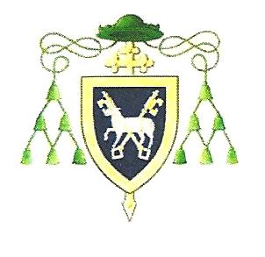

Learning and Teaching

 | Indicators | Embedded | Developing | Needs to be addressed
1. | Teachers have the highest expectations of themselves and their pupils.
2. | A culture of ‘inspiration’ and ‘aspiration’ permeates the school.
3. | Catholic values are explicitly and consistently reflected in all curricular and extra-curricular activities.
4. | The uniqueness of each pupil is recognised and celebrated.
5. | Teachers model Catholic attitudes, values and behaviours.
6. | Teachers have a strong belief in the ability of all children to succeed.
7. | The Learning and Teaching policy recognises the needs of all children.
8. | Teachers actively build pupils’ self-confidence and self-esteem.
9. | The learning environment is stimulating and well organised.
10. | The pedagogy is purposeful, interesting and engaging.
11. | Pupils’ work is praised and publicly celebrated.
12. | Processes are in place for effective planning and regular monitoring and evaluation of classroom practice to ensure continuous improvement in outcomes for pupils.
13. | Marking for improvement and constructive feedback are key components of the effective learning and teaching process.
14. | There are positive and meaningful relationships between teachers and pupils within an ethos which challenges and supports pupils to achieve their best.
15. | Teachers actively seek and are given opportunities to continue their professional development and to seek to deepen their personal spirituality.
16. | The curriculum is regularly reviewed to ensure the provision of a broad, balanced and relevant Learning and Teaching environment.

In the coming year our school will give further attention to indicator number:

