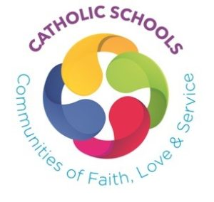
Insert
School
Crest
If desired
A Charter For Catholic Schools
Key Stage 1

Catholic schools are communities inspired by the spirit and message of Christ. Christ’s commandment to “love one another as I have loved you” promotes an ethos which is:

Gospel-inspired: It gives living witness to the Gospel values of love, respect, truth and justice in ervery aspect of school life.

Person-centred: It promotes the dignity, self-esteem and full development of all, as persons made in the image and likeness of God.

Life-affirming: It promotes a positive culture of respect for life at all its stages, proclaiming the ‘Good News’ of life to the full and an eternal life of love to come.

Reflective and Worshipping: It encourages an open and inquiring approach to faith and learning, promoting opportunities for reflection, prayer and celebration of the sacraments.

Welcoming and Inclusive: It welcomes and is respectful of people of all faith traditions, personal circumstances and community backgrounds, contributing actively to the work of peace, reconciliation and sharing.

Insert School Name
Mission Statement/Motto/Strapline

In our school we show God’s love by

- Being kind to others
- Caring and sharing
- Being a friend
- Looking after the environment
- Praying together
I agree to try my best to show God’s love as set out in the Name of school Catholic Primary School Charter

____________________________ _________________________
Child Parent
______________________________
Date

